* **AI Project**
* **Stock Market Prediction Using Machine Learning**

**Submitted by: Team 4**

Bhargav Gurram

Sai Venkat Gunnapaneni

Kundana Janga

**Abstract:** The prediction of the stock market has entered a technologically enhanced era with the arrival of technical wonders like worldwide digitalization, redesigning the traditional methodology of trade. Stock trading has evolved into a major area of investing for many financial investors due to the continuous rise in market capitalization. Several analysts and academics have created methods and systems that forecast stock price changes and aid investors in making wise choices. Researchers can forecast the market using unconventional textual data from social platforms thanks to advanced trading models. The prediction accuracy has significantly improved with the use of modern machine learning techniques like text data analytics and ensemble methods. Due to dynamic, unpredictable, and chaotic data, stock market analysis and forecasting remain to be among the most difficult research fields. This paper uses the implementation of a general framework to explain the systematics of machine learning-based systems for stock market prediction. Results from the 2011–2022 time period were analyzed critically after being acquired from digital databases. To determine the direction of importance, a thorough comparison study was also done. The study would be beneficial for new researchers to comprehend the fundamentals and developments of this developing field, carrying out further research in exciting directions.

**Introduction**: Stock prediction is the science of forecasting a stock's future performance based on its historical performance and the state of the market. Stock prediction in the S&P 500 can be done with precision and simplicity using Python code. The methods and strategies utilized to predict stocks in the S&P 500 will be covered in this session. The S&P 500 is a grouping of 500 of the biggest American publicly traded corporations. It is frequently used as a benchmark for the entire stock market by analysts and investors. Investors can choose their investments wisely by predicting the future performance of these stocks. Investors look for strategies and instruments that will boost profits while lowering risks. Yet, due to its non-linear, dynamic, stochastic, and inaccurate nature, Stock Market Prediction (SMP) is not an easy process. SMP is a type of time-series forecasting that rapidly analyzes past data and predicts the values of future data. Analysts from a variety of fields, including economics, mathematics, material science, and computer science, have expressed concern about the ability to predict financial markets. Making money off of stock trading is a crucial component of stock market forecasting. In the past, this view was generally held. Researchers found that stock market values might be foreseen to a certain degree with the development of technology. To forecast changes in the economic and business sectors, analysts might blend historical market data with information gleaned from social media networks. The quality of the features a stock market prediction system uses has a significant impact on how well it performs. While several techniques for improving stock-explicit features have been employed by academics, more focus needs to be placed on feature extraction and selection procedures.

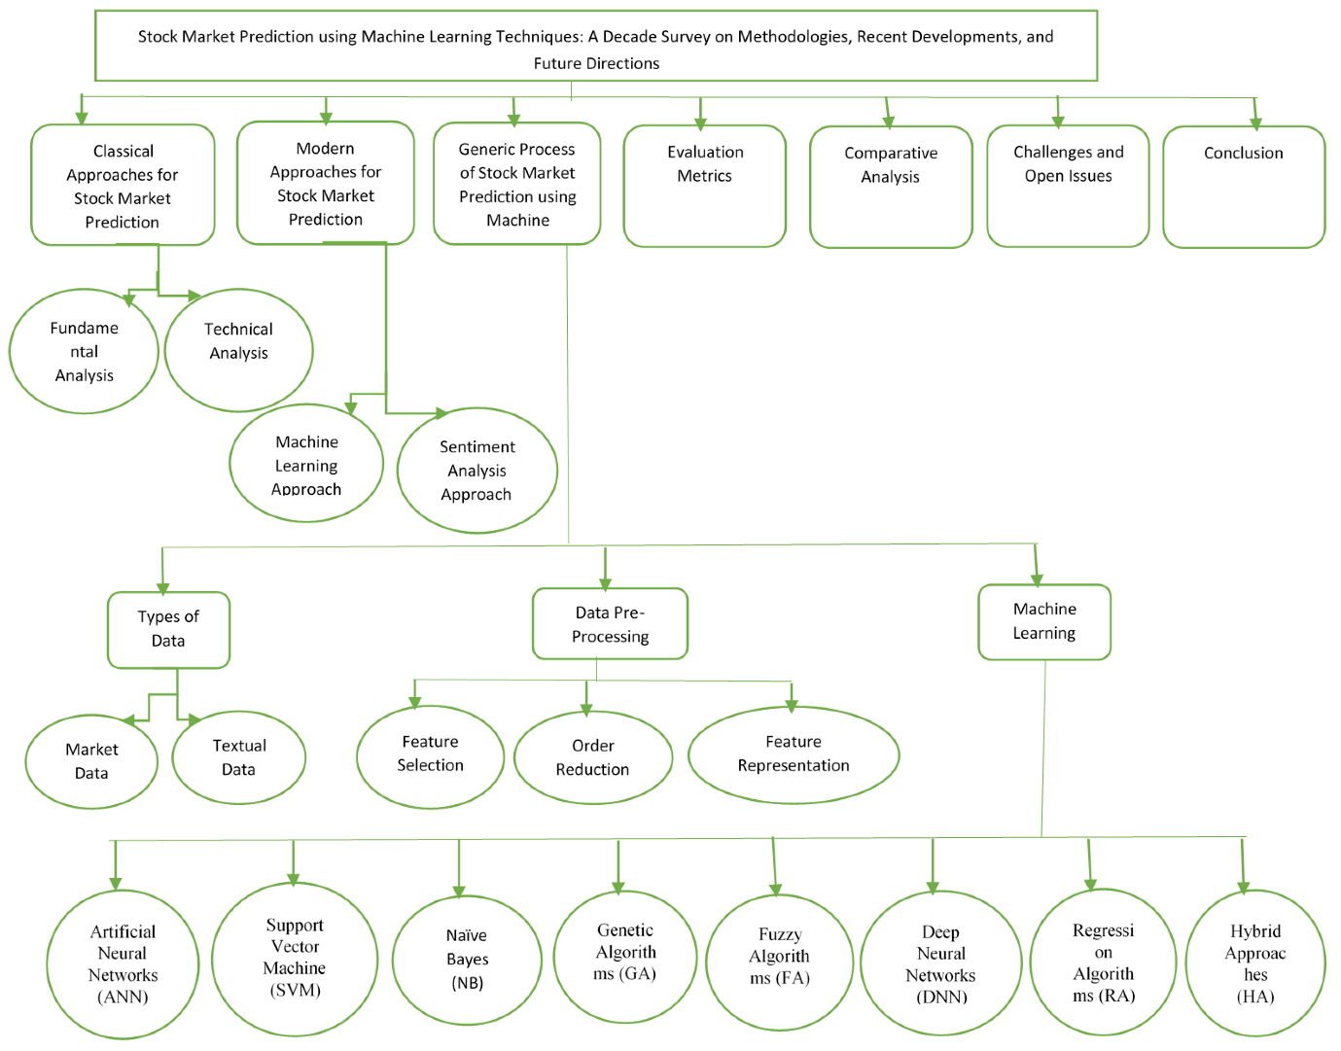

**Fig no 1:** outline of the stock market prediction: -

* Fundamental analysis and technical analysis are the two primary conventional methods for studying stock market prediction.
* **Fundamental Analysis:**

Fundamental analysis evaluates a sector's or company's true value and establishes the price at which a share of that company should trade. It is assumed that, given enough time, the business will adjust its costs to match the forecast. The market value of a corporation should increase if a sector or company is undervalued, while the market price should decrease if a sector or company is overvalued. The study is conducted taking into account a number of variables, including annual financial summaries and reports, balance sheets, a future prospectus, and the work environment of the organization. The market price will decrease if equities are overvalued. The Price to Earnings ratio (P/E) and the Price by Book ratio (P/B) are the two metrics that fundamental analysts most frequently use to forecast long-term price fluctuations each year. One predictor is the P/E ratio. Compared to businesses with a high P/E ratio, those with a lower P/E ratio produce higher returns. This is often used by financial analysts to support their stock recommendations. Financial ratios can be considered using fundamental analysis to differentiate between low-quality and high-quality stocks. Undoubtedly, fundamental analysis is a useful technique. Nonetheless, it has some shortcomings. Basic analysis, first, lacks sufficient understanding of the laws guiding how the system functions, and second, the system is non-linear.

* **Technical Analysis:**

Technical analysis is the study of stock prices with the goal of making money or improving investment choices. Technical analysis uses technical indicators to examine financial time series data and anticipate stock prices by predicting the direction of future price movements of equities based on their past data. Meanwhile, it is considered that the price has momentum and moves in a trend. Technical analysis, which is mostly utilized by short-term investors, makes use of price charts, certain formulas, and patterns to forecast future stock values. When the time points are daily, weekly, monthly, or yearly, the price would be termed high, low, open, or closing price of the stock. The three main tenets of technical analysis put forward by the Dow theory are that prices move in trends, the market price discounts everything, and historical trends typically repeat themselves. According to, one of the technical analysis's obvious faults is that the rules are set and resistant to change because they are determined by the opinions of experts. There is disregard for several factors that influence stock pricing.

* **Machine learning Approach:**

Global digitization has ushered in a technological era for SMP. To find trends in data, machine learning is employed in stock price prediction. Typically, stock markets generate a vast amount of heterogeneous structured and unstructured data. It is feasible to swiftly evaluate more complicated heterogeneous data and get more precise findings by using machine learning algorithms. For SMP, a variety of machine-learning techniques have been employed. Unsupervised and supervised machine learning techniques are the two primary categories. With the supervised learning strategy, the learning algorithms are given named input data and the desired output. The learning algorithm is given unlabelled input data in the unsupervised learning approach, where the system recognizes patterns and produces the output in accordance with those patterns.

* **Research Methodology:**

The entire methodology for the review on SMP utilizing machine learning is described in this part. The term "stock market prediction using machine learning" was first associated with several search engines, digital libraries, and databases, such as "google scholar," "research gate," "ACM digital library," "IEEE Explore," "Scopus," and others. Several terms, like "stock market prediction methods," "effect of sentiments on stock market prediction," and "machine learning-based methodology for stock market prediction" were keyed in during the process of collection.

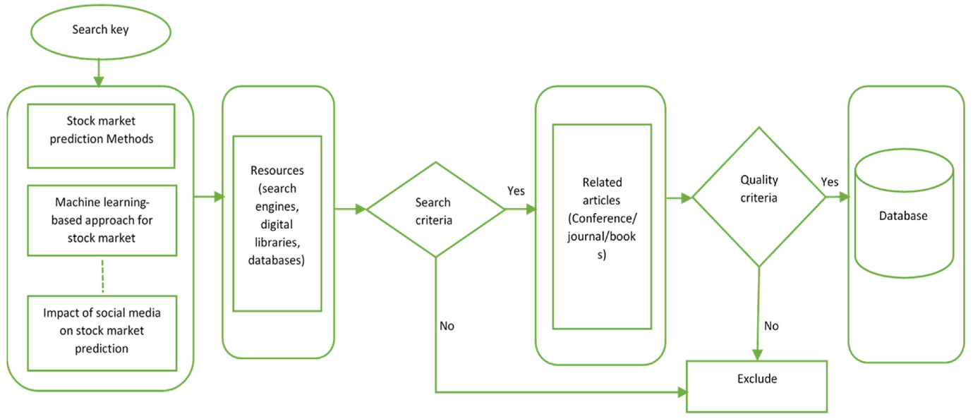

**Fig no:2** The collection process of stock market prediction.

* **Generic Scheme for stock market prediction:**

Data collection and pre-processing are the first steps in the procedure before the data is fed into a machine-learning model. Market and textual data are the two forms of data that the prediction models often use. The next part talks about both genres of literature. Based on the type of data used, the prior studies are categorized in the following area. In addition, the next part covers earlier research based on various data-pre-processing techniques used.

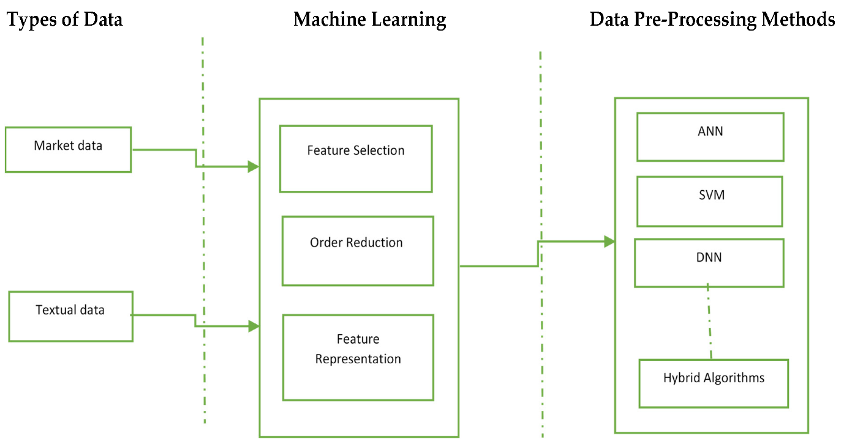

**Machine learning methods:** The machine learning models that were employed in earlier studies for stock forecasting and prediction are summarized in this section. The input is supplied to machine learning models for additional processing after being pre-processed and converted to a common format.

* Artificial Neural Networks (ANN).
* Support Vector Machine (SVM).
* Genetic Algorithms (GA).
* Fuzzy Algorithms (FA).
* Deep Neural Networks (DNN).
* Regression Algorithms (RA).
* Hybrid Approaches (HA).
* **Testing and deployment:**

The model is tested using actual data after it has been developed and assessed. This makes it more likely that the model will be able to predict future stock prices with accuracy. After the model has been tested, investors can use it by deploying it to a web or mobile application.

The testing and deployment process is automated by Python, which makes it simpler and quicker for analysts. Investors may now more easily use the stock prediction model, enabling them to make well-informed investing decisions.

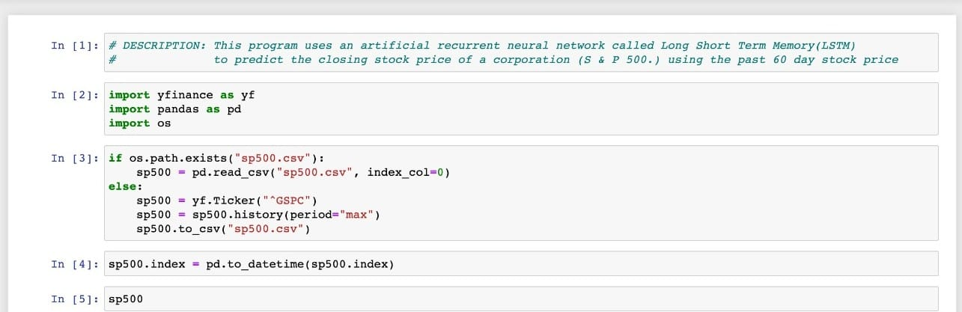

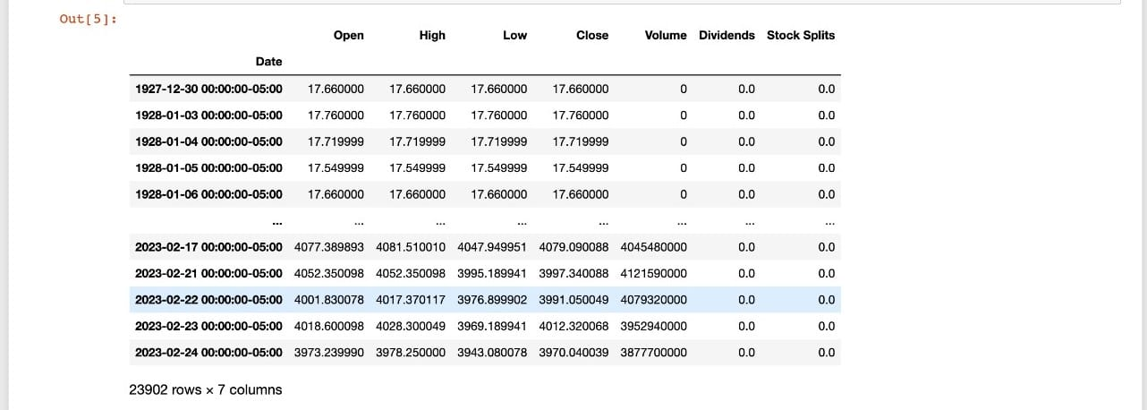

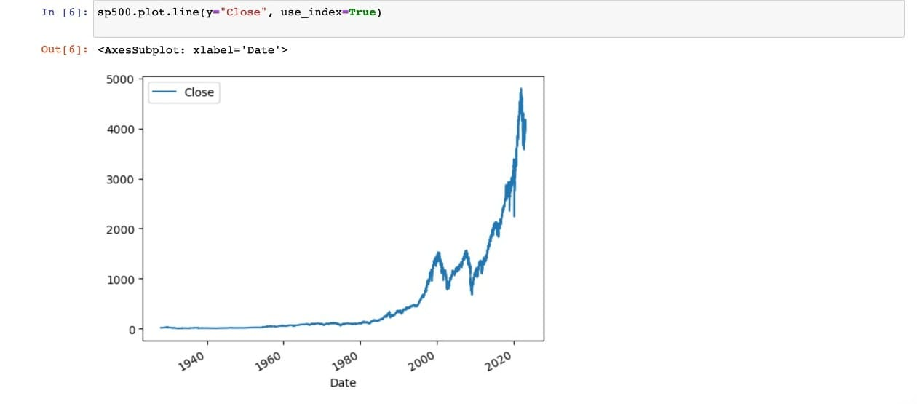

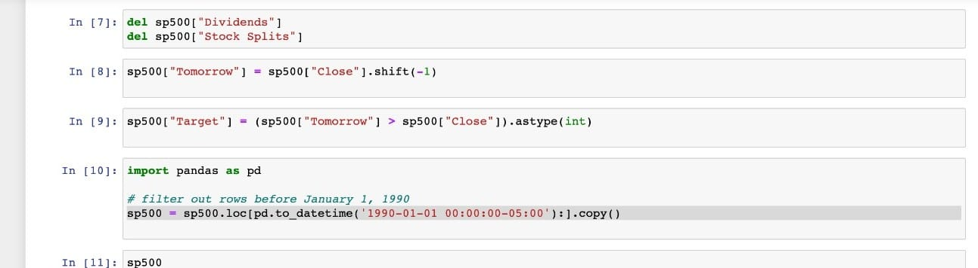

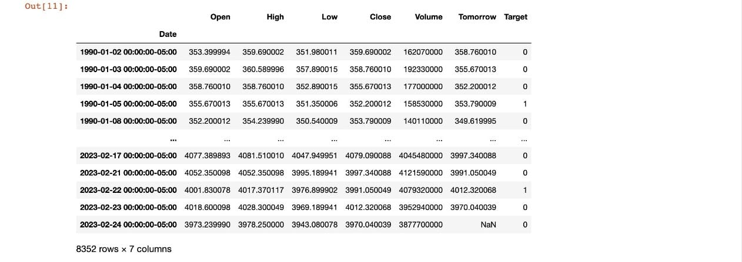

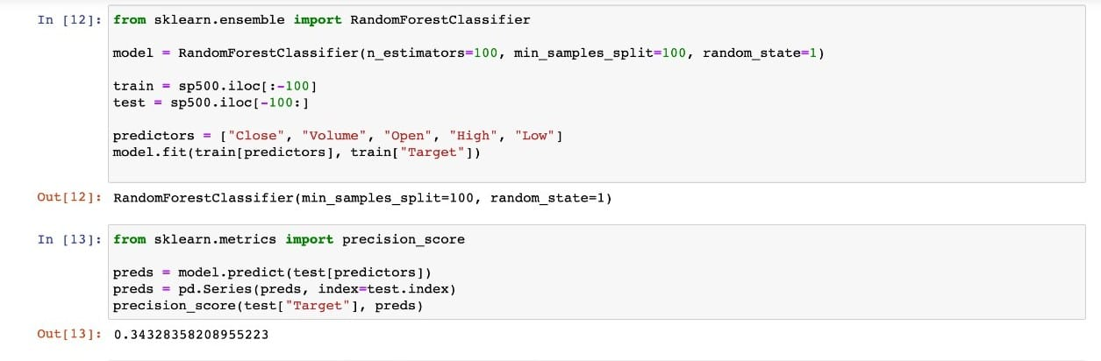

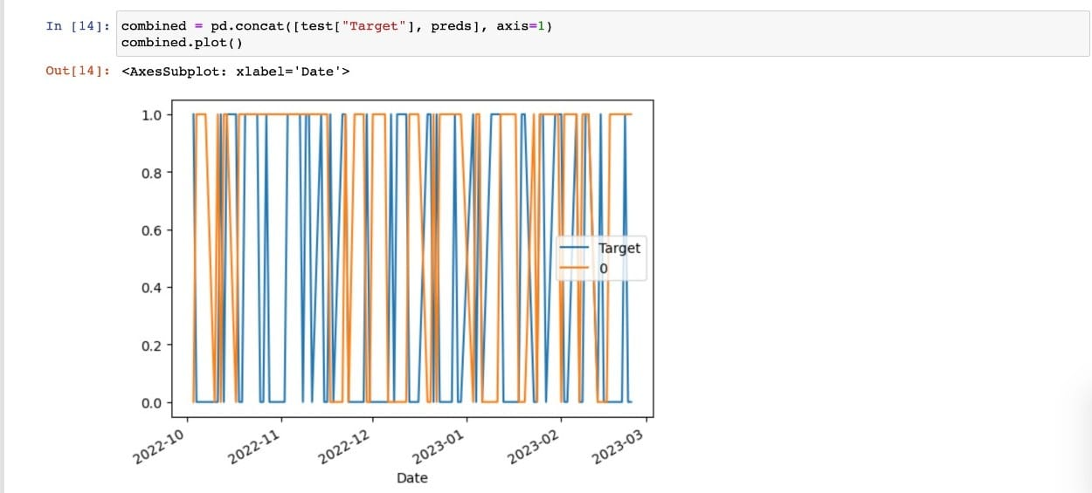

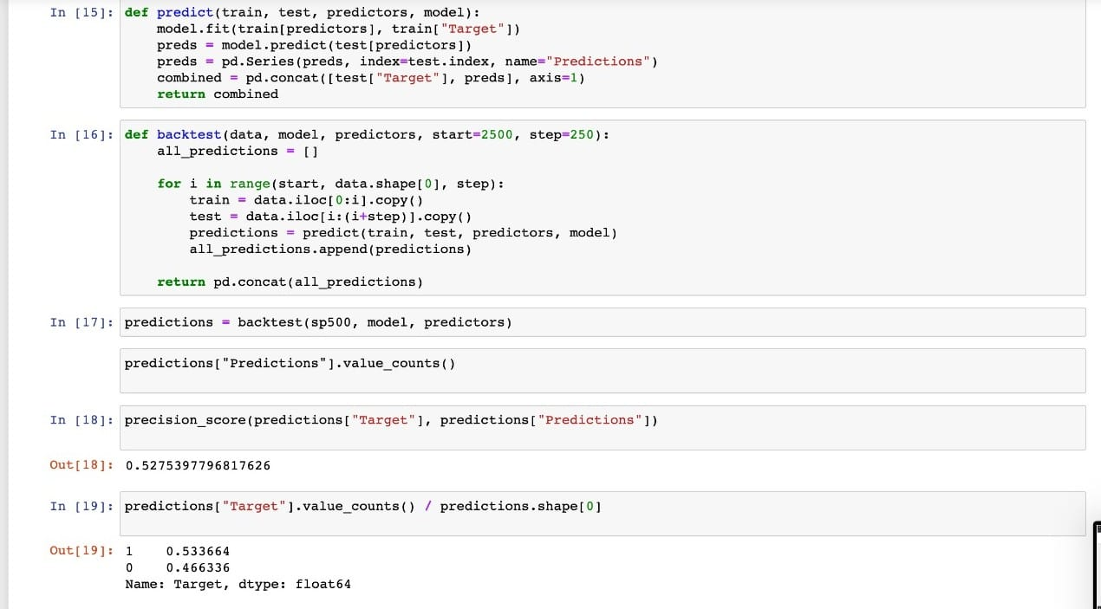

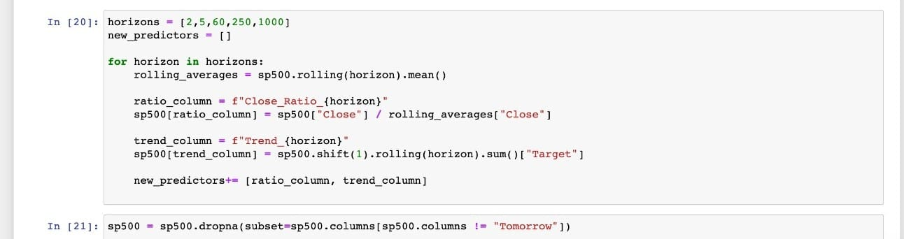

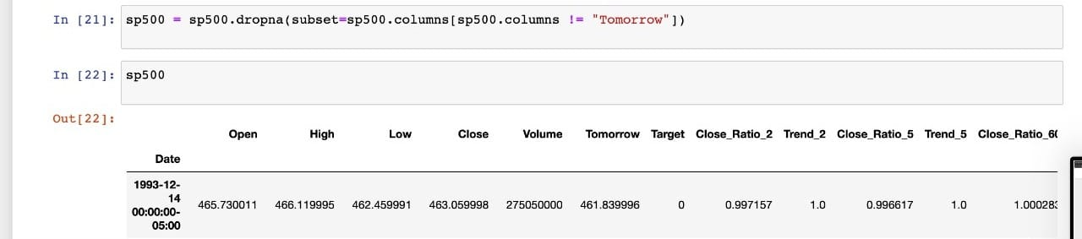

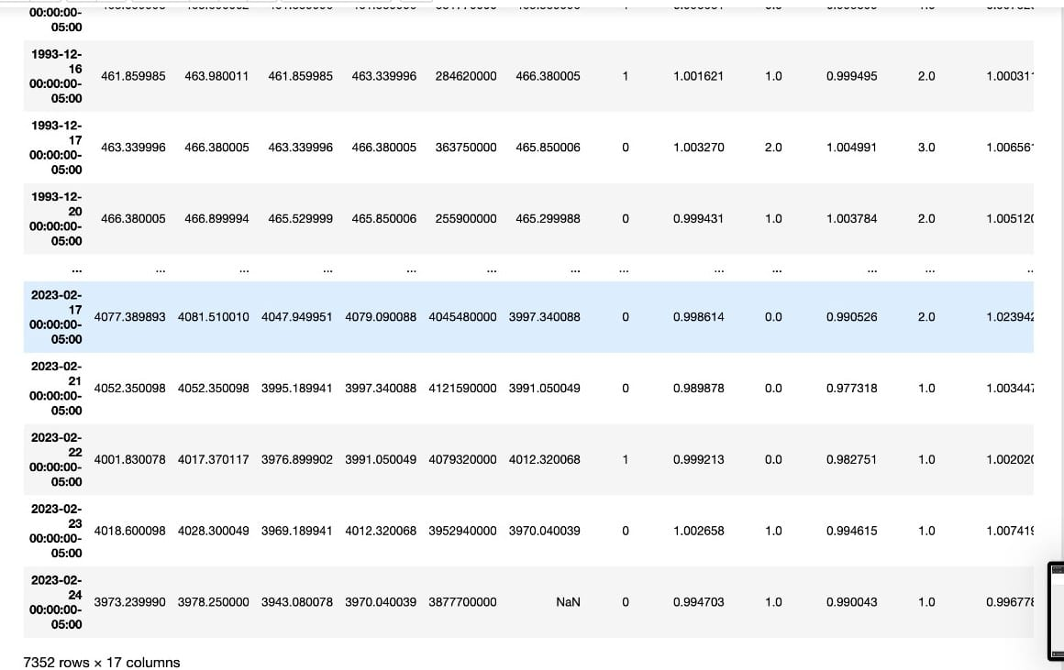

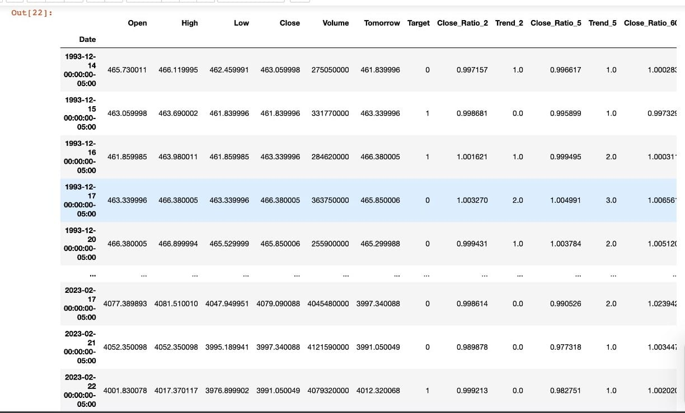

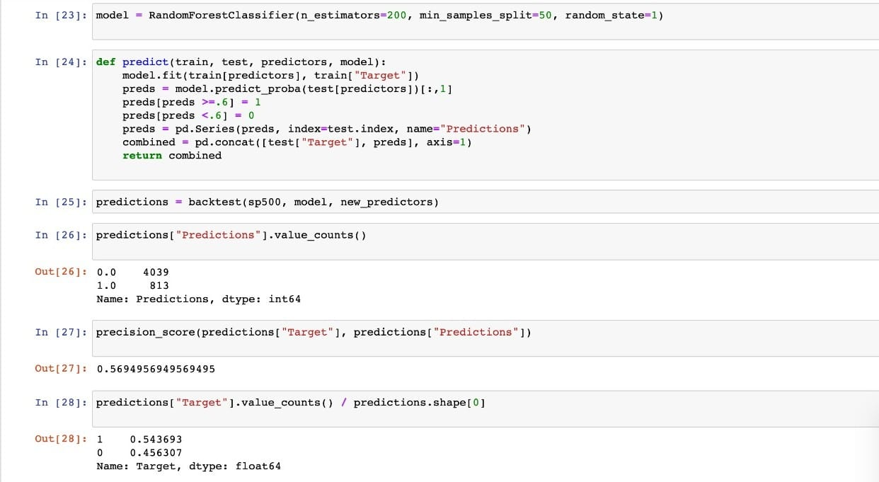

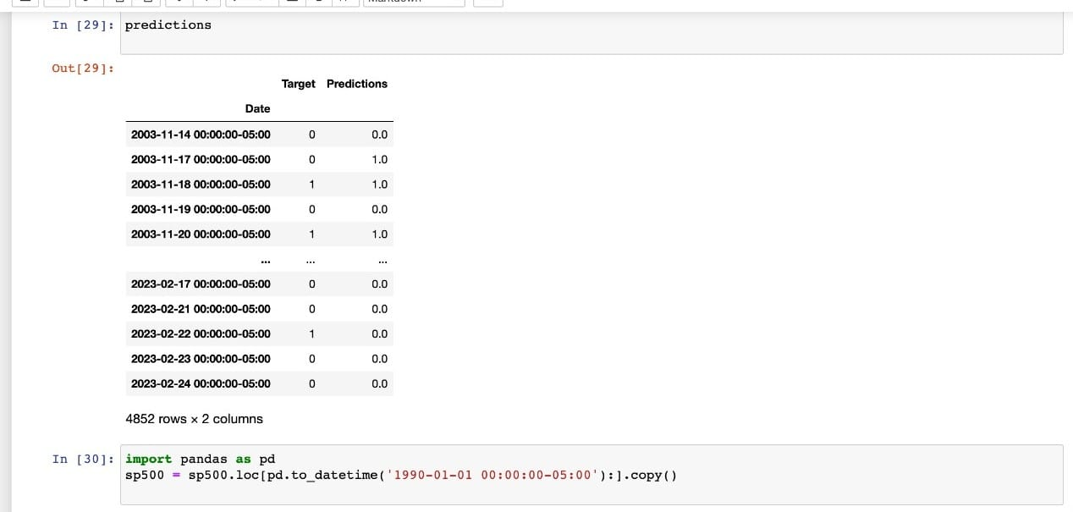

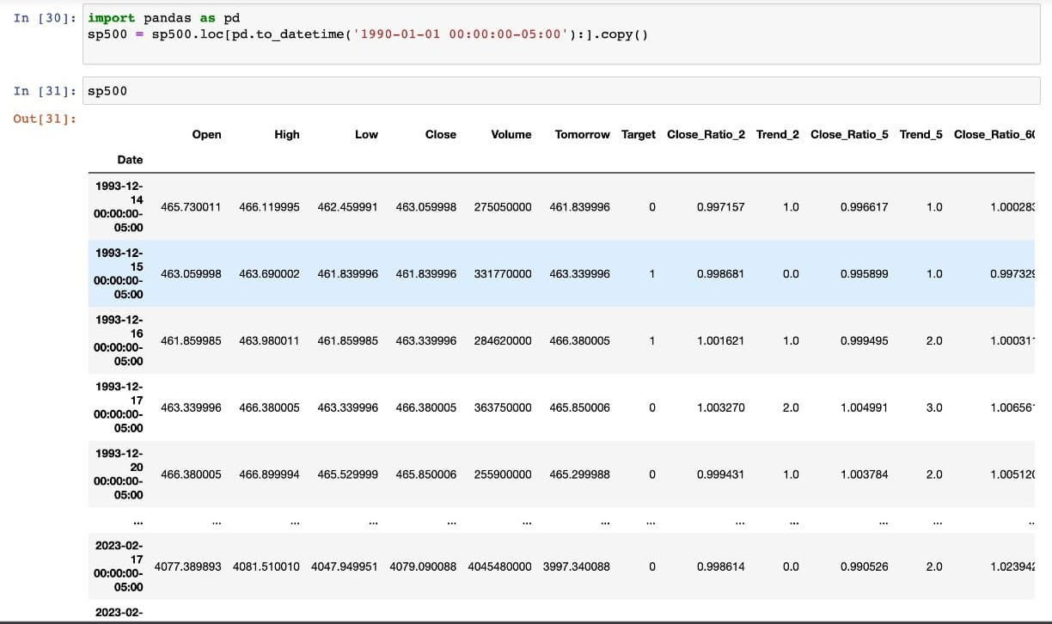

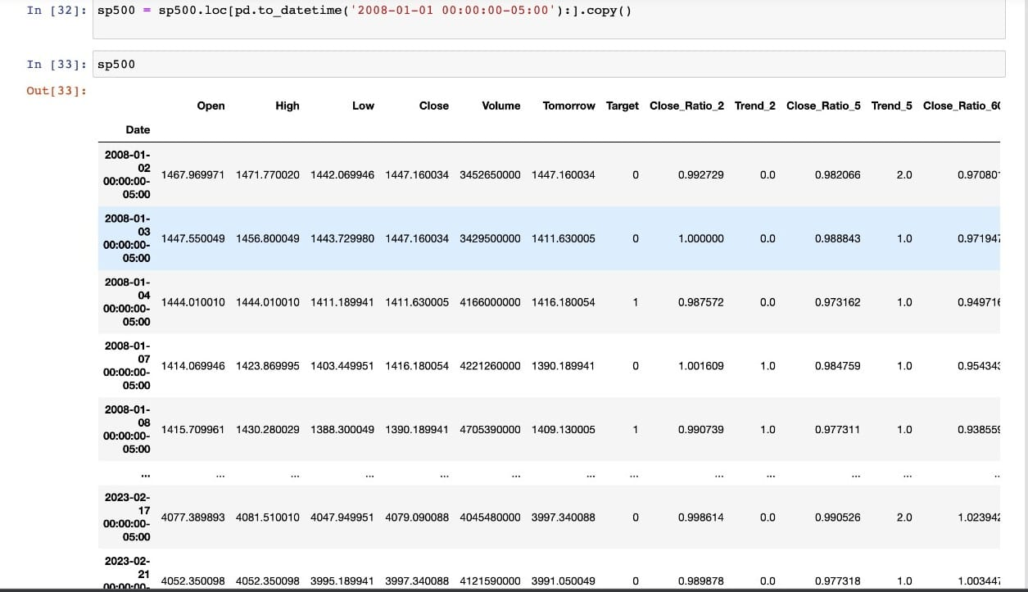

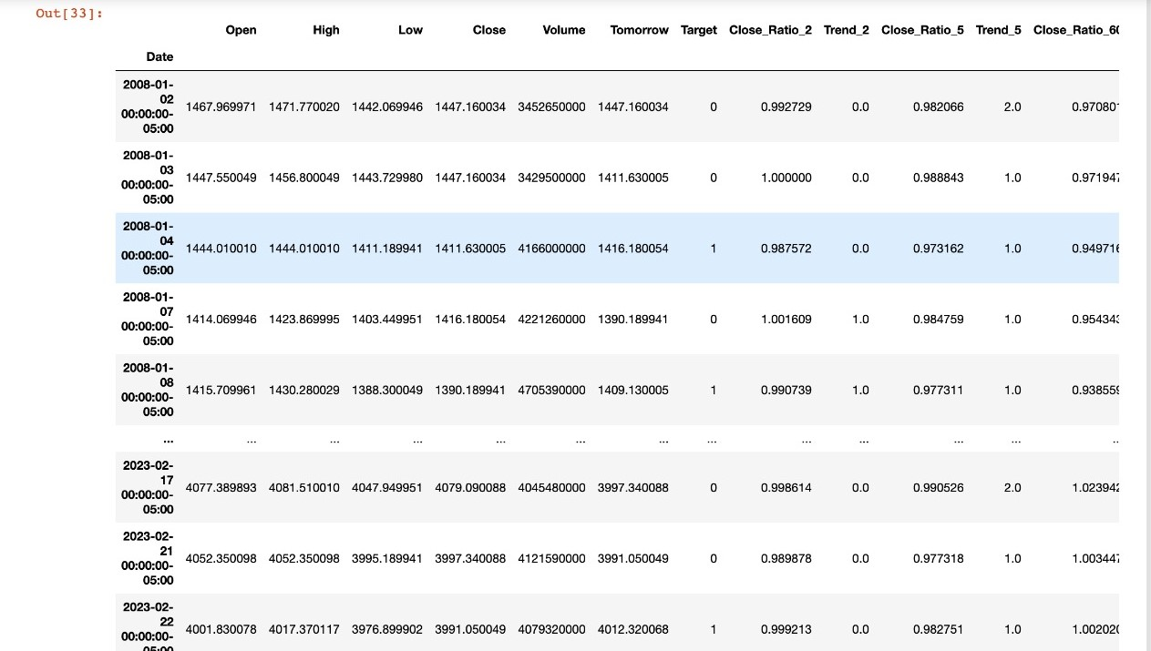

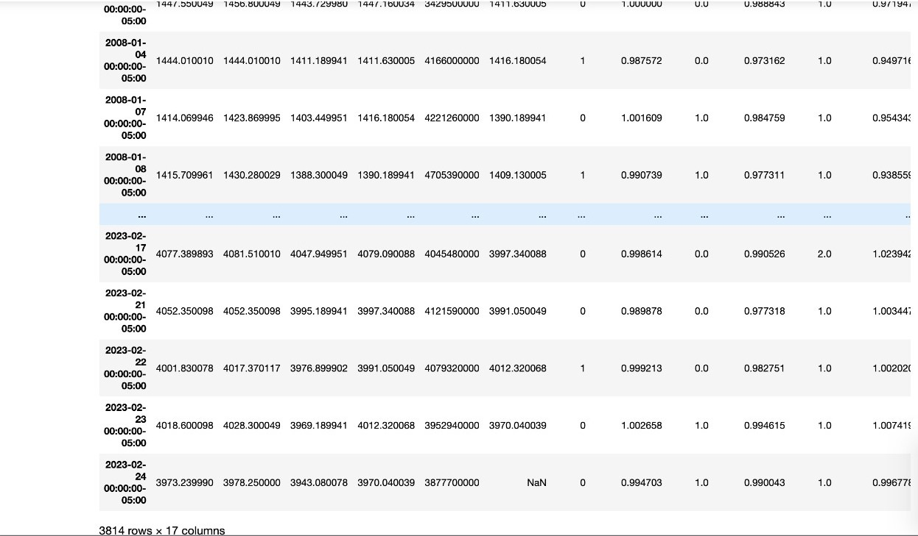

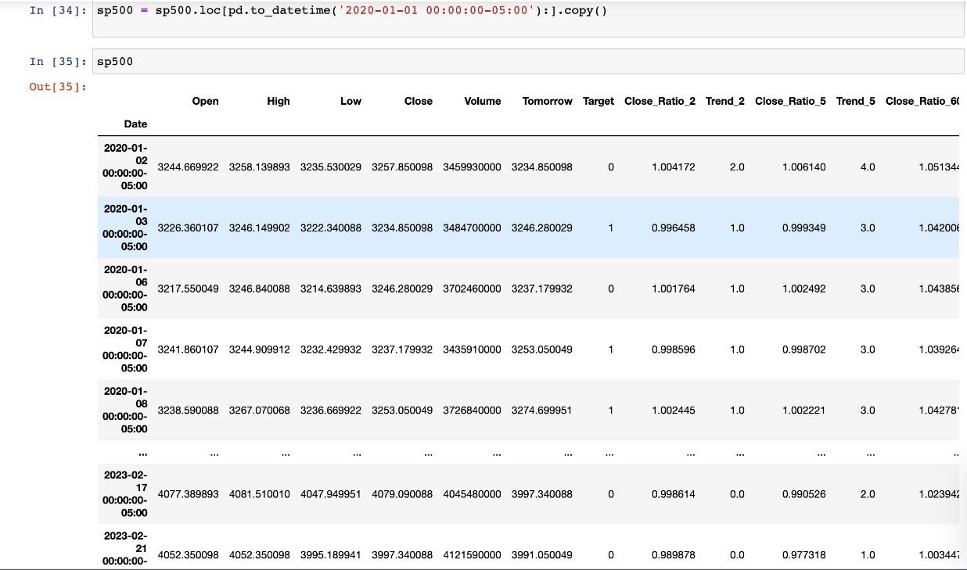

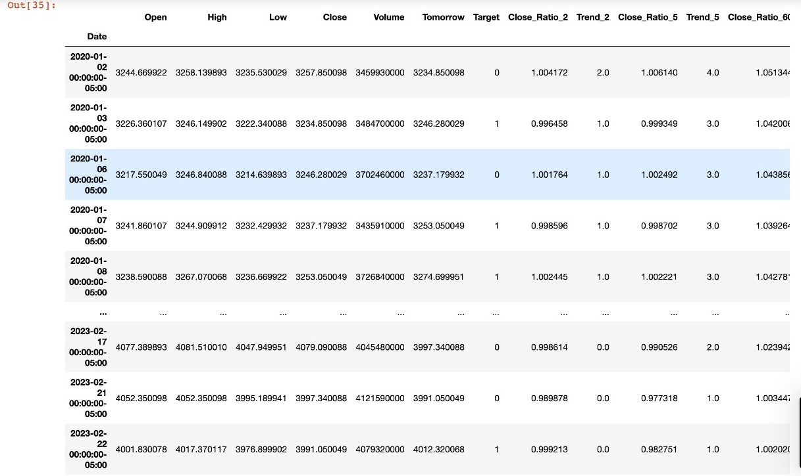

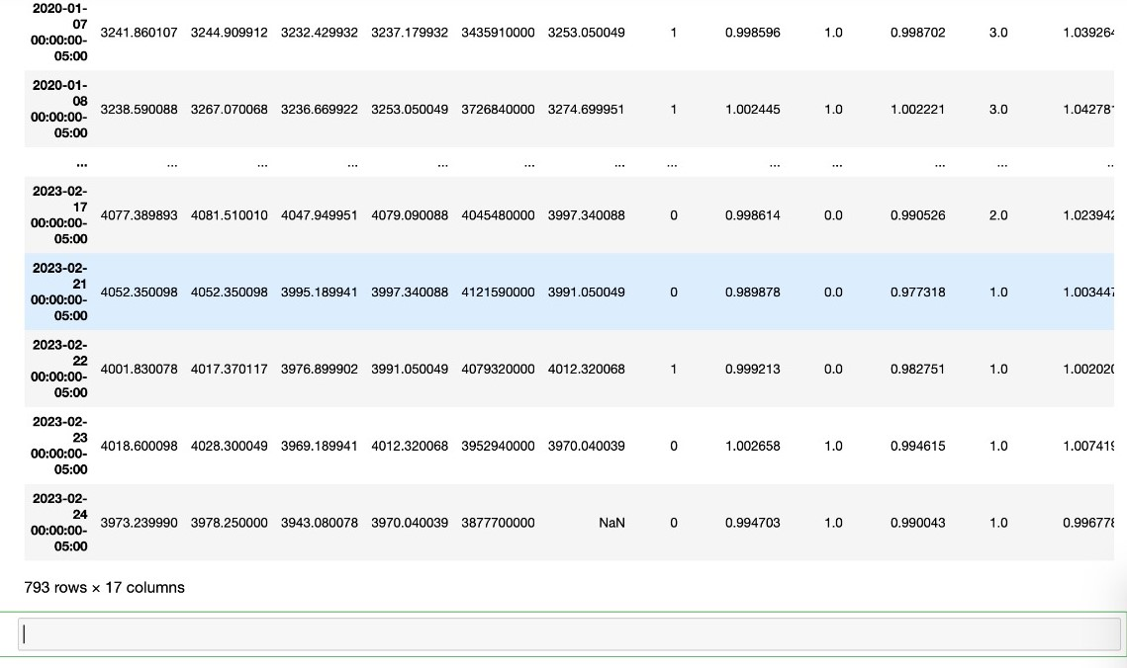

## **Challenges:**

* Analysis and forecasting of the financial markets remain an interesting and difficult topic. Access to data is getting simpler nowadays, but it's getting harder to collect and process it so you can get useful insights out of it and assess how it affects stock prices. It is difficult to extract features from financial data since it is important to recognize the variety of variables that are utilized to make predictions.
* Events that cause panic selling are occurring more frequently today, and they cause market overreaction. Fear and loss trigger panic selling, which results in the massive sale of investments. In such circumstances, it becomes more challenging for a researcher to assess market behavior.
* It is tough to assess the sufficiency and accuracy of these algorithms as new ones continue to enter the markets at a rapid rate. The self-defeating nature of this field of study is remarkable. Simply put, sharing highly profitable procedures with other businesses will make those approaches obsolete.
* Market volatility is the degree of swings in an investment's market price. Uncertainty and inflation are the key causes of volatility, and a volatile market increases risk. Volatility constantly affects our emotions in negative ways. When the market is erratic, predicting stock values is difficult.
* Either humans or bots can produce the data on social networking sites. human emotions can also lead to incorrect predictions. As a result, social bot identification is required to get better predictions. The potential risks posed by social bots are constantly being reported by investigators, analysts, and researchers. Investors in the market take part in and respond to views expressed on social media. As a result, it can be concluded that social platform data significantly influences stock prediction.

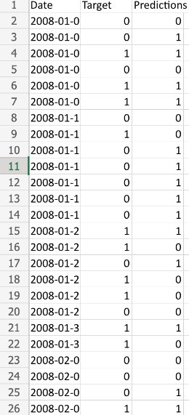

* Stock market predictions in the year 2008.

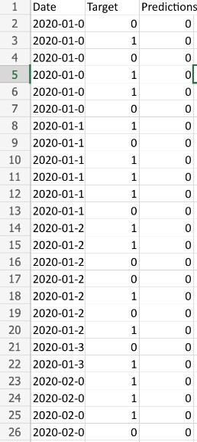

* Stock market predictions in the year 2020.

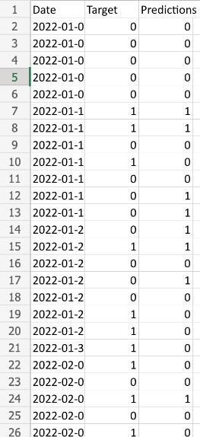

* Stock market predictions in the year 2022.

**Advantages:**

1. Making educated judgments is made easier thanks to stock prediction, which gives investors information about a stock's anticipated future performance. This information helps them decide whether to buy, sell, or hold a certain stock.
2. Returns are maximized: By foreseeing future stock market fluctuations, investors may make calculated investment choices that will increase their profits.
3. Reduces risk: Correct stock predictions can assist investors in lowering the likelihood that they will experience stock market losses. Investors may make better investing selections if they are aware of the benefits and dangers associated with a specific asset.

**Disadvantages:**

1. Despite the use of statistical models, there are still a number of unknowns that might impact how accurate the forecasts are. The stock market may be strongly impacted by unexpected occurrences like natural catastrophes, political upheavals, and technology disruptions.
2. Restricted range: Since stock prediction algorithms rely on previous data, they could not account for unforeseen occurrences that have never happened before. Because of this, it is difficult to estimate market performance properly and the scope of predictions is constrained.
3. Overreliance: Investors who base their whole investing choice primarily on stock predictions may become overly dependent on them. Due to this, investors may neglect the stock's basic examination and develop blind spots in their investment methods.

**Conclusion:**

* Stock prediction in S&P 500 can be done with accuracy and convenience with the aid of Python coding. The primary steps in the process include data gathering and pre-processing, model development and assessment, testing, and deployment. These procedures are automated with Python, which makes them simpler and quicker for analysts.
* Investors may choose wisely what to invest in by forecasting the future performance of stocks. The procedure and methods utilized to predict stocks in the S&P 500 have been covered in this presentation.
* SMP is being carried out using machine learning, big data analytics, and deep learning, which offer more optimal decision-making than traditional frameworks. Today's stock markets are susceptible to cyberattacks and social media sentiment. By creating the foundations for better and more safe trade, researchers may play a vital role and thrive in these fields.

**References:**

* [1] Masoud, Najeb MH. (2017) “The impact of stock market performance upon economic growth.” International Journal of Economics and Financial Issues 3 (4) : 788–798.
* [2] Murkute, Amod, and Tanuja Sarode. (2015) “Forecasting market price of stock using artificial neural network.” International Journal of Computer Applications 124 (12) : 11-15.
* [3] Hur, Jung, Manoj Raj, and Yohanes E. Riyanto. (2006) “Finance and trade: A cross-country empirical analysis on the impact of financial development and asset tangibility on international trade.” World Development 34 (10) : 1728-1741.
* [4] Li, Lei, Yabin Wu, Yihang Ou, Qi Li, Yanquan Zhou, and Daoxin Chen. (2017) “Research on machine learning algorithms and feature extraction for time series.” IEEE 28th Annual International Symposium on Personal, Indoor, and Mobile Radio Communications (PIMRC): 1-5.
* [5] Seber, George AF and Lee, Alan J. (2012) “Linear regression analysis.” John Wiley & Sons 329
* [6]. S. Mohan, S. Mullapudi, S. Sammeta, . V. Parag and. D. C. Anastasiu, "Stock Price Prediction Using News Sentiment Analysis," International Conference on Big Data Computing Service and Applications, pp. 205-208, 2019.
* [7]. G. Abdulsattar, S. S. Kamaruddin and H. Husni,"Stock Market Classification Model Using Sentiment Analysis on Twitter Based on Hybrid Naive Bayes Classifiers," Computer and Information Science, vol. 11, pp. 52-64, 2020.
* [8]. R. Akita, A. Yoshihara, T. Matsubara, and K. Uehara, "Deep Learning for Stock Prediction Using Numerical and Textual Information, "Authorized licensed use limited to: IEEE Xplore,2020.